**Project 3 – Scrolling Display with MAX7219**

Sketch simulates a graphic equalizer using a 32x8 LED array controlled by MAX7219s. This particular one displays MLB scores from August 8, 2018.

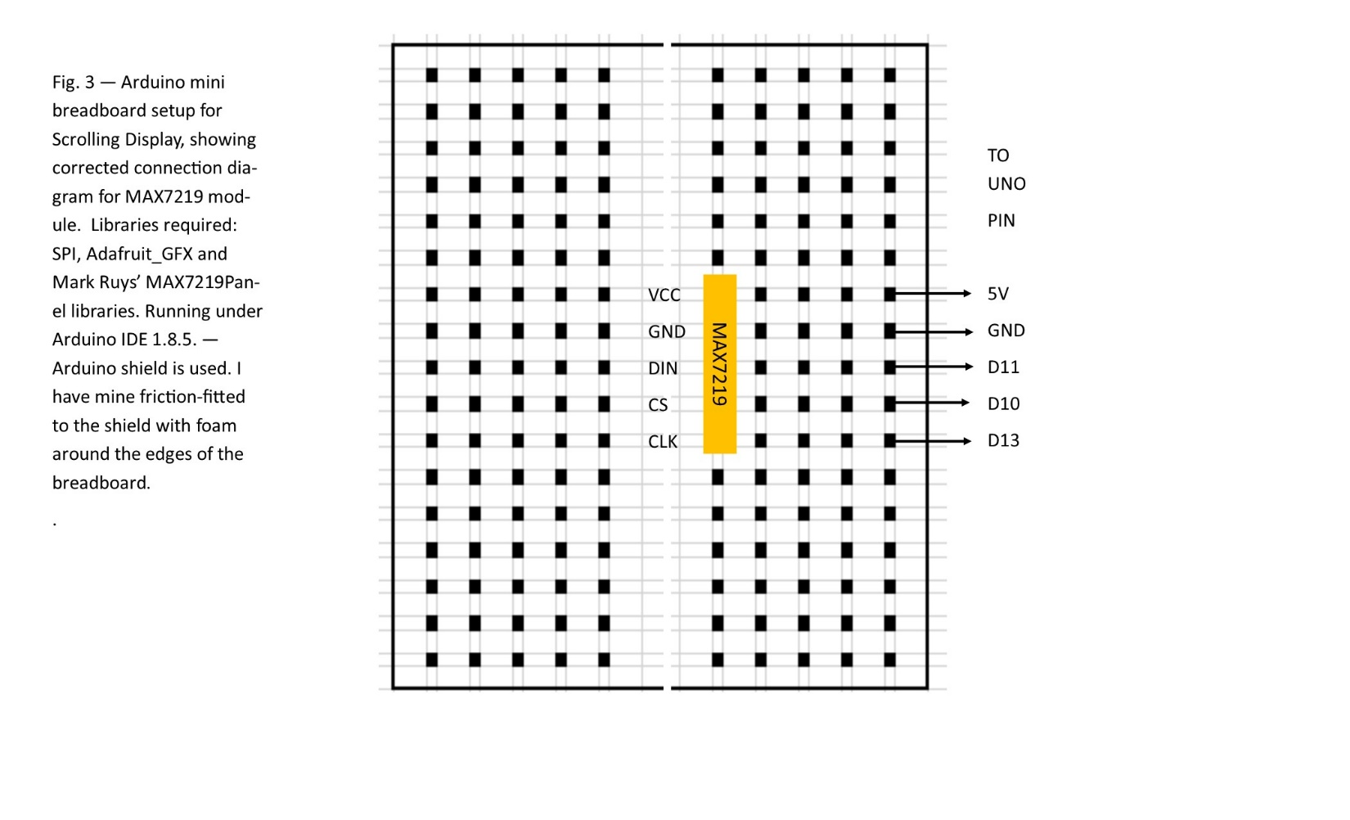

Code for Scrolling Display

#include <SPI.h>

#include <Adafruit_GFX.h>

#include <Max72xxPanel.h>

// Connection chart for 8x32 LED array

// MAX7219[0] UNO

// ---------- ---

// VCC 5V

// GND GND

// DIN D11

// CS D10

// CLK D13

int pinCS = 10; // Attach CS to this pin, DIN to MOSI and CLK to SCK (cf http://arduino.cc/en/Reference/SPI )

int numberOfHorizontalDisplays = 4;

int numberOfVerticalDisplays = 1;

Max72xxPanel matrix = Max72xxPanel(pinCS, numberOfHorizontalDisplays, numberOfVerticalDisplays);

String tape_sacrifice = "Arduino"; //This string traps the smileyface and heart characters, imprisioning them forever.

String tape = "MLB Scores 08/08/2018 CIN 0, NYM 8 SEA 7, TEX 11 PIT 4, COL 3 PHI 0, ARI 6 DET 0, LAA 6 ATL 8, WSH 3 BOS 10, TOR 5 BAL 5, TB 4 MIN 2, CLE 5 STL 7, MIA 1 NYY 7, CWS 3 SD 4, MIL 8 CHC 0, KC 9 LAD 2, OAK 3 ";

int wait = 40; // In milliseconds

int spacer = 1;

int width = 5 + spacer; // The font width is 5 pixels

void setup() {

matrix.setIntensity(7); // Use a value between 0 and 15 for brightness

// Adjust to your own needs

matrix.setPosition(0, 0, 0); // The first display is at <0, 0>

matrix.setPosition(1, 0, 1);

matrix.setPosition(2, 0, 2);

matrix.setPosition(3, 0, 3);

// ...

matrix.setRotation(0, 1); // rotate 90 deg clockwise

matrix.setRotation(1, 1); // rotate 90 deg clockwise

matrix.setRotation(2, 1); // rotate 90 deg clockwise

matrix.setRotation(3, 1); // rotate 90 deg clockwise

// Boot Screen

matrix.fillScreen(HIGH);

matrix.drawChar(4,1,'T',LOW,HIGH,1);

matrix.drawChar(10,1,'E',LOW,HIGH,1);

matrix.drawChar(16,1,'S',LOW,HIGH,1);

matrix.drawChar(22,1,'T',LOW,HIGH,1);

matrix.write();

delay(1000);

matrix.fillScreen(HIGH);

matrix.write();

delay(1000);

matrix.fillScreen(LOW);

matrix.drawChar(4,0,'P',HIGH,LOW,1);

matrix.drawChar(10,0,'A',HIGH,LOW,1);

matrix.drawChar(16,0,'S',HIGH,LOW,1);

matrix.drawChar(22,0,'S',HIGH,LOW,1);

matrix.write();

delay(1000);

}

void loop() {

for ( int i = 0 ; i < width * tape.length() + matrix.width() - 1 - spacer; i++ ) {

matrix.fillScreen(LOW);

int letter = i / width;

int x = (matrix.width() - 1) - i % width;

int y = (matrix.height() - 8) / 2; // center the text vertically

while ( x + width - spacer >= 0 && letter >= 0 ) {

if ( letter < tape.length() ) {

matrix.drawChar(x, y, tape[letter], HIGH, LOW, 1);

}

letter--;

x -= width;

}

matrix.write(); // Send bitmap to display

delay(wait);

}

}